**Fi-Ware Social Proximity App**

Research Document

Joshua Eisikovits: C00156665

Project Supervisor: Dr Chris Meudec

17/04/2015

u

Table of Contents

Abstract 5

Similar Applications 6

Proximity 6

Oxegen App 7

Electric Picnic App 9

Overall Conclusion and Possible Feature Implementations 10

Platforms and Types of Applications 11

Introduction 11

Native 11

Local Native Platform Examples 11

Android 11

Advantages of Android 12

Disadvantages of Android 13

Android Conclusion 13

iOS 14

Advantages of iOS 14

Non-Native Platforms (Web Applications) 15

Non-Native Example 15

Google Docs 15

Advantages of Google Docs 15

Disadvantages of Google Docs 15

Hybrid Platforms 16

Hybrid Example 16

Titanium 16

Titanium Studio 16

Advantages and Disadvantages of Platforms 17

Native App Benefits 17

Native App Disadvantages 18

Non-Native App Advantages 18

Non-Native App Disadvantages 18

Hybrid Advantages 18

Chosen Platform for Fi-Ware Social Proximity App 19

Cloud Computing 20

Introduction 20

SaaS (Software as a Service) 20

PaaS (Platform as a Service) 20

IaaS (Infrastructure as a Service) 20

Advantages of Cloud Computing 21

Disadvantages of Cloud Computing 21

Push Notifications 21

Push Notifications on a Mobile Device 21

Technologies Used During Project 22

Fi-Ware Vision and Goals 22

Fi-Ware Lab 22

Fi-Ware Generic Enablers 22

Creating a Virtual Infrastructure 23

Java Servlets and Apache Tomcat 26

Advantages of Java Servlets 26

Java Servlets Architecture 26

Servlet Packages 26

Apache Tomcat 27

Apache Components 27

Catalina 27

Coyote 27

Jasper 27

Version Control 28

Git 28

Web Technologies 29

HTML 29

CSS 30

Advantages of CSS 30

JavaScript 31

Advantages of JavaScript 31

Disadvantages of JavaScript 31

REST API 32

Advantages of REST API 32

Databases 33

Relational Databases 33

MySQL 33

Distributed Databases 33

Problems Encountered During the Project 35

Connectivity with the College Network and Fi-Ware 35

Difficulties with Java Servlets and Titanium Appcelerator 36

Posting JSON Data from Mobile Device 36

References 38

# Abstract

This document is the first document of many regarding the Fi-Ware Social Proximity application. The aim of the research document is to gain a greater understanding about the technologies that are available that could be used to develop this project.

# Similar Applications

There are many other applications out there available to download which are similar to the Social Proximity App.

# 

# Proximity

Ref [1]

Description

Discover who is around you and interact with people who you are close to or anywhere on the map. Follow your favourite users.

Total Downloads

100 - 500

Requirements

Android 2.1 and up

Useful Features

* follow close friends around you
* locate people around you

Screenshots

Ref [1]

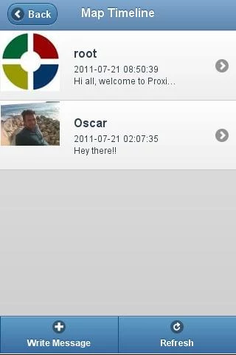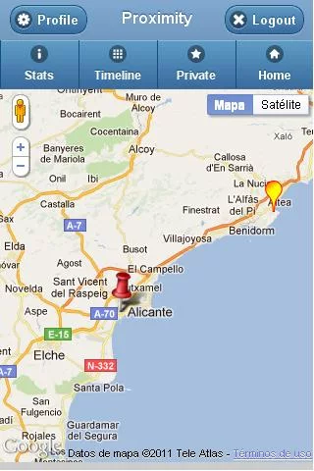

# Oxegen App

Ref [2]

*Description*

Oxegen is the official iPhone app for the Oxegen Music Festival in Punchestown, Ireland. Ireland’s largest music festival, spanning three days with some of the world’s top music acts.

Useful Features

* The app provides features such as an interactive event planner to schedule your gig plan for Oxegen and share that plan with your friends through the app.
* GPS tracking to allow you find everything on the site, including your friends in real time via Facebook.
* Kit list so that you’ll never forget all the festival essentials. Directions, news, twitter, updates from your favourite artists and live traffic updates throughout the weekend.

Requirements

iOS 4.0 or later, compatible with iPhone, iPad and iPad

Useful Features

* Simple but effective home screen with button icons for easy navigation
* Site map for the event, can use devices GPS location to direct you towards destination
* Can find Facebook friends using GPS
* Photo gallery to save images from event

Screens

Ref [2]

Main Menu Site Map Gallery

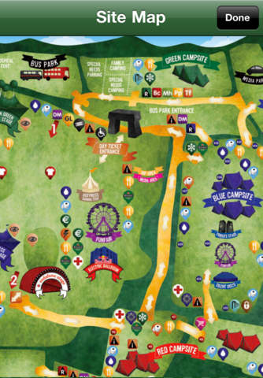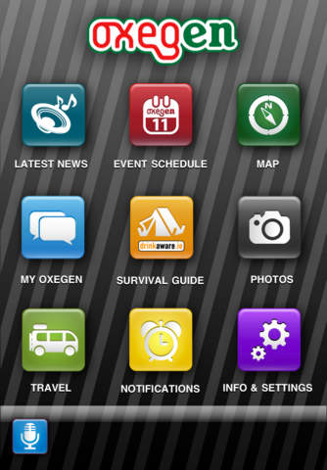

# Electric Picnic App

Ref [3]

*Description*

Electric picnic app is the official app for the musical Festival in Stradbally Hall Co. Laois, Ireland.

Useful Features

* The app provides timetables and reminders so you don’t forget about acts performing on the weekend.
* Can look up detailed information about artists
* Has a built in map to direct you to and from campsites/acts
* Has a chat wall so users can comment about Electric Picnic, other users can see these comments and have the choice to reply or not.

Requirements

iOS 4.0 or later, compatible with iPhone, iPad and iPad

Useful Features

* Simple but effective home screen with button icons for easy navigation
* Site map for the event, can use devices GPS location to direct you towards destination
* Can find Facebook friends using GPS
* Photo gallery to save images from event

Screens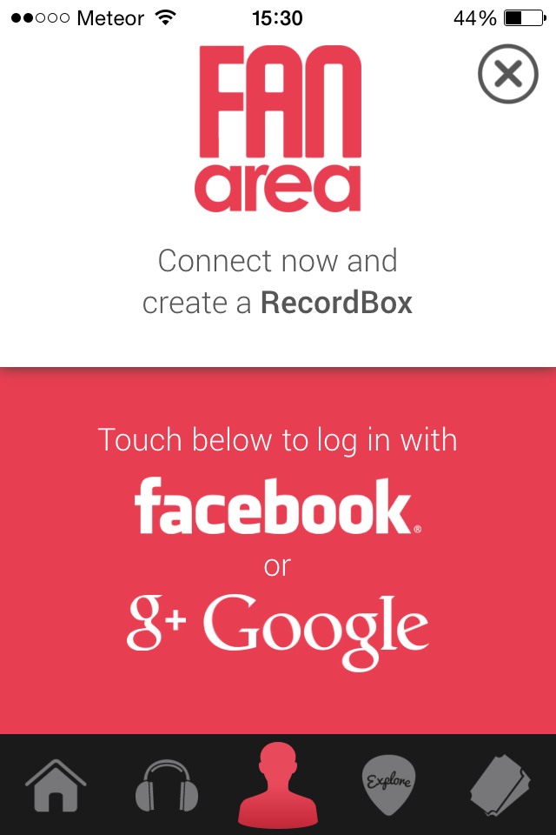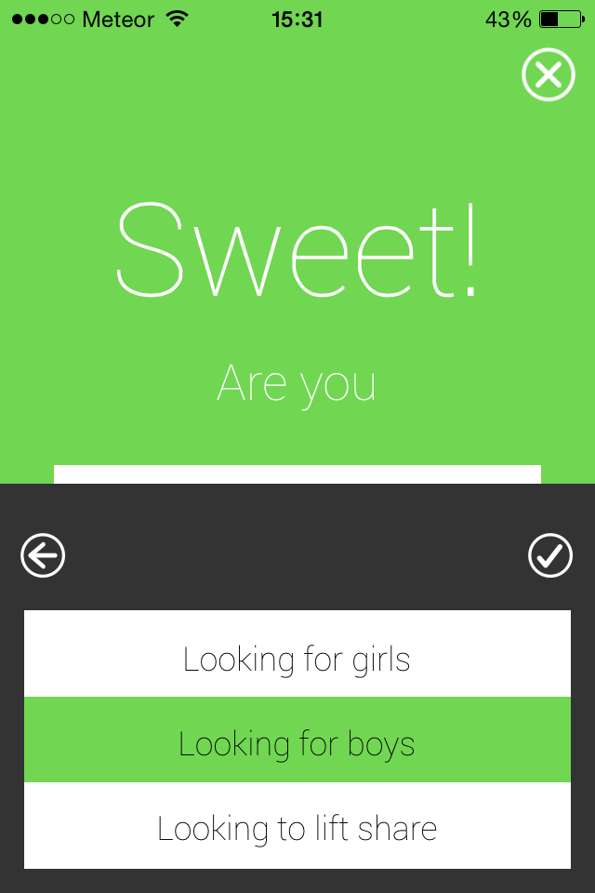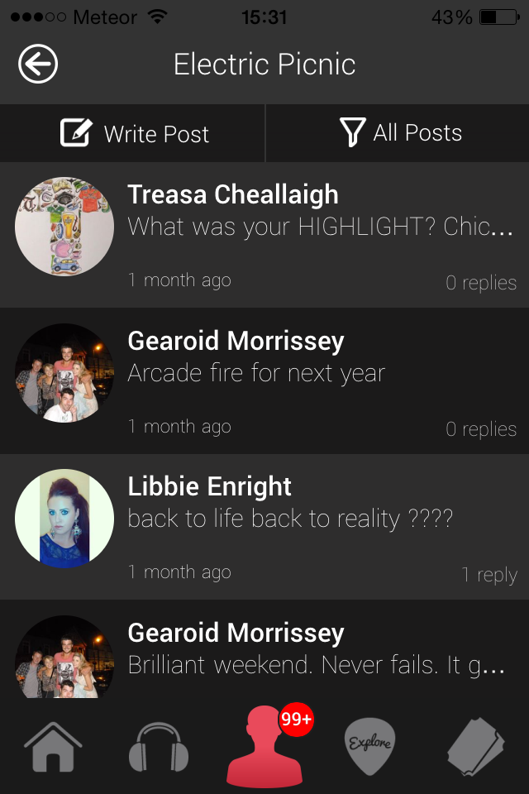

Ref [3]

# Overall Conclusion and Possible Feature Implementations

Proximity App

With the very few downloads the Proximity application is near impossible to use or locate someone close by. After downloading and testing the application on an android device I can say that the application runs smoothly, with the integrated use of Google Maps it is very easy to view the surroundings around your current location, however as there was no other users close by I could not test the full functionality of the application.

Oxegen

After downloading and testing the Oxegen app on an iPhone I was extremely impressed with the design and user interface. Once i started the application I had the choice of signing in with Facebook or as a guest, if you choose to sign in with Facebook the app will allow you track your friends in real time via GPS.

The app is a pretty good application with appropriate features added in such as the site map, gallery and real time notifications. However, If the app could somehow interpretate an anonymous chat between people at this social event I think it would boost the downloads as people are always looking to meet new friends especially based on the same interests.

Possible Feature Implementation

* Social Media connection for registration (e.g. Google Account, Facebook) users find it annoying to carry on registering details, allow users to pull details from other accounts.
* Allow users to select a distance for people who they are allowed to chat with i.e. 200 meters or 2 kilometres, this could be highly useful at events.

# Platforms and Types of Applications

# Introduction

In this section the different types of applications along with their individual benefits and setbacks will be discussed. The three types of application technologies that will be discussed are Native, Non-Native and Hybrid.

# Native

A native application (native app) is an application program that has been developed for use on a particular device or platform Ref [4].For example:

* xCode/Objective-C for iOS
* Eclipse/Java for Android
* Visual Studio/ C# for Windows Phone

As native apps are written for specific platforms, these types of applications can take advantage of the operating system they were developed for. For instance the latest technology on a mobile phone could be global position system (GPS), cameras and microphones. This could be highlighted as an advantage for native apps over Non-Native and Hybrid.

The term native app is mainly used in the same context with mobile computing. This is due to the fact that mobile applications have been written (coded) to work on a specific device platform. A native app is installed directly onto a mobile device. The app may be stored on the device when you take it out of the box or from an app store which is then installed on the device.

# 

# Local Native Platform Examples

# Android

Android is an extremely popular mobile operating system, as you can see from the diagram below Android has outshone iOS devices by over one hundred million in 2014. One of the major reasons is due to the fact that Android mobile devices are substantially cheaper that iOS devices.

Android OS is based on the Linux kernel which enables apps it to be run on many devices. Android supports applications on tablets, mobile phones, smart watches and game consoles. Therefore Android OS will be a platform in heavy contention for developing the social proximity application.

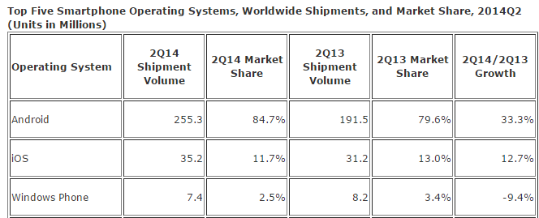Ref [5]

# Advantages of Android

An important advantage is that Android is Linux based therefore it is open source, meaning that no industry even the Google Play Store (where most android apps are distributed) will be able to restrict developers or introduce any changes that go against them. Unlike the iOS, developers for android have full access to the phones functionality (SMS, using the camera).

Secondly is the distribution of Android applications. The Google play store has had around 25 billion apps downloaded in over 130 countries worldwide. The fee also for developers is only a once off payment of $25 Ref [6], compared to a yearly fee of $99 for iOS developers. The Google play store allows users who have downloaded applications to leave a rating as well as feedback this can help developers in future iterations of updates.

Another benefit of developing for android is the amount of resources and training available online to beginner and experienced developers. Google offers online plugins (a software component that adds more features to an existing software application) for integrated development environment (IDE) such as Eclipse. As well as an Android Software Development Kit that contains libraries necessary to build and test your own apps, finally that leads us to java. If you want to develop for Android all you need to know is Java and the Android API for java. Unlike Objective C and C++/C java is a very powerful programing language which has been around for many years. Again there are hundreds of video tutorials as well as articles available to developers.

# Disadvantages of Android

Although Android has a fantastic reputation and some astonishing stats there are some downfalls, for instance;

* During some applications android suffers from lagging and continuously hanging your phone resulting in you closing the application that you’re running.
* It is safe to say if you have an android mobile device you need to be connected to the internet to get the full potential of its services, play store and Google services.
* As there are a lot of processes occurring in the background this may cause the battery to drain quickly. (Although this could be contradicted with new handheld devices being released with more improved battery capacity and processing power).
* Because app development is somewhat extremely easy to professional developers, sometimes there is a lot of advertising inside applications. Although it does not interfere with the application itself it can become annoying.

# Android Conclusion

The main advantages to consider if the Android operating system is the most appropriate platform to develop the Fi-Ware Social Proximity Application.

* Open Source, less restrictions for developers.
* Developed in Java programming language, plenty of tutorials based on java.
* Apps don't need to be approved to go on play store plus only a onetime fee of 25$ for publishing applications

Free software development kits for developers to use.

# iOS

Ref [7]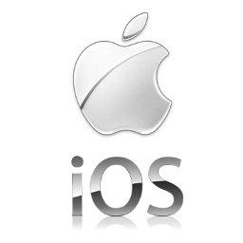

iOS (previously known as iPhone OS) is an innovative mobile operating system developed by Apple, released in 2007 iOS has been extended to support other Apple devices such as the iPad. iOS is definitely a recognised competitor towards Android as off 2013 Apples App Store (distribution off apps) held more than 1 million iOS applications. It is also estimated that these apps have been downloaded over 60 billion times Ref [8].

## 

# Advantages of iOS

One of the most important benefits of the iOS is how user friendly the operating system is, for instance zooming in and out of the screen (viewing a web page) is easily done by using you two fingers bringing them closer or further away from each other, as well as holding down on the screen will open a type of magnifying glass which is highly beneficial to the users who are visually impaired. iOS offers to users their own type of Skype(video chat) communication called FaceTime where the connection quality is off a much higher standard.

Another standout feature iOS has is Siri. Siri is Apples iOS personal assistant, the application uses a natural language interface to answer questions, make recommendations or ring/text contacts. Siri is an integral part of iOS and is now being integrated into vehicles in the near future.

## 

# Non-Native Platforms (Web Applications)

Non-Native or most of the time referred to as Web Applications (or HTML5) is an application program that is stored on a remote server and is delivered over the internet through a browser interface Ref [9]. These applications use existing web technologies such as HTML5, CSS, JavaScript and more web technologies to make the application feel more like it is run on local machines such as mobile devices.

# Non-Native Example

# Google Docs

Google Docs is a free Web-based application written in Java Script, which allows users to create documents and spreadsheets which can be stored online. Files can be accessed anywhere from a computer or mobile device with an Internet connection. Ref [10]

# Advantages of Google Docs

* Users can write, edit and collaborate wherever you are for free.
* Great editing tools to insert pictures tables and drawings at no additional cost.
* There are many mobile applications for phones and tablets, which support various native platforms such as iOS and Android.
* Documents and spread sheets can be shared between many users. Therefore all users can work on the same document together.
* Automatically saves data as users’ type.

Ref [11]

# Disadvantages of Google Docs

* Limited formatting ability.
* Can experience lag during peak hours.
* Multiple users working on the same document can be frustrating as the document may alter in position etc.

Ref [12]

# Hybrid Platforms

Hybrid applications, like native apps run on the device but are written with web technologies primarily HTML5 and JavaScript. Hybrid applications combine the best of both native and non-native, hybrid is best defined as a web app but inside is a native container Ref[13] that provides access to the native platform features (GPS, camera etc.).

# Hybrid Example

# Titanium

Ref [14]

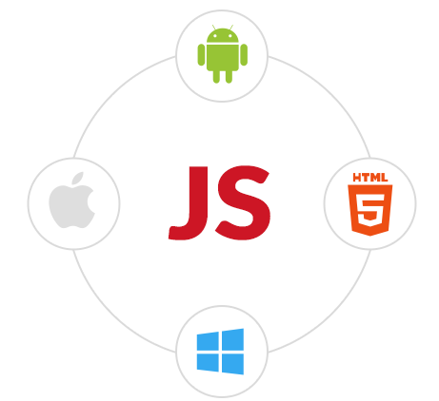Appcelerator Titanium is an open-source framework that allows user to create mobile apps on platforms such as iOS, Android, Windows Phone and Blackberry OS from a single JavaScript codebase. In February 2013 ‘Business Insider’ estimated that 10% of all smartphones worldwide ran Titanium-built apps.

All application source code gets deployed to the mobile device where it is interpreted using a JavaScript engine, Mozillas Rhino is used on Android and Blackberry and Apple’s Javascriptcore for iOS.

Appcelerator Titanium is an open, extendable development environment for creating native apps across different mobile devices (Android, iOS) as well as hybrid and HTML5.

With the ability to build rapidly, test and publish mobile apps using only one code base JavaScript. Developers with web development skills can quickly build rich ‘hybrid/mobile’ apps. There is no longer need to manage multiple languages and development kits. Ref [14]

# Titanium Studio

Benefits

* A single environment for coding, debugging and publishing mobile apps
* Taking advantage of the simplicity of JavaScript and cross-platform code reuse

An Eclipse-based IDE and JavaScript enables traditional and web developers to become mobile experts. Ref [15]

# Advantages and Disadvantages of Platforms

Ref [20]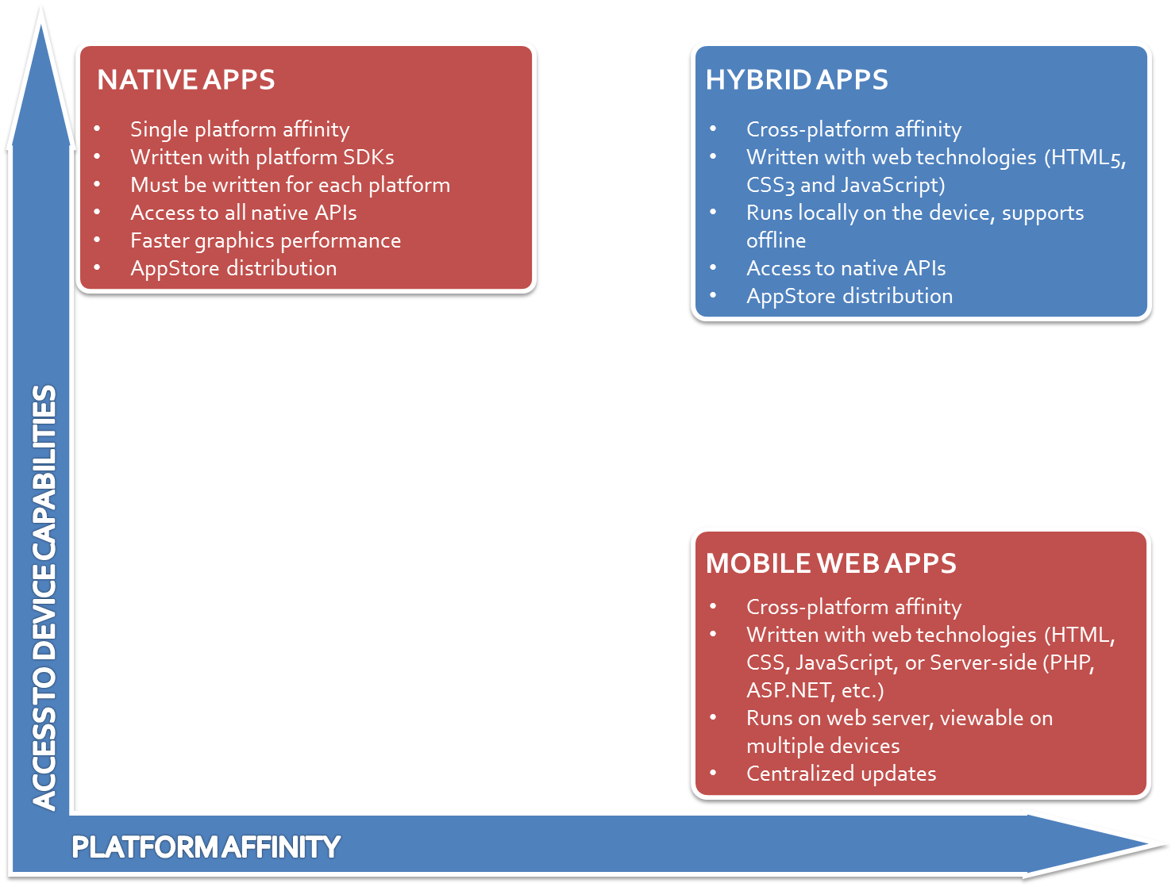

To conclude the discussion on different application types the diagram above really emphasizes the advantages/disadvantages of each.

# Native App Benefits

* Access to all native APIs (Application Programmable Interfaces) - allowing the use of the desired platform operating system to its benefit (e.g. GPS, Camera etc.)
* Faster graphics performance, as a native app is designed only for the chosen platform it doesn't have to alter its graphics or interface to suit other platforms
* Offline functioning - a native app is best if your app must work when there is no connectivity, whereas mobile web apps depend on information coming from a server.

# Native App Disadvantages

* Must be written for each platform, this is a major flaw for native applications because if the application was an Android app for instance and the owners wanted to hit more of the market for feedback (e.g. iOS app) the whole application would have to be produced again using a different platform and a software development kit. This is costly in terms of time and development.

If the application depends heavily on graphics performance, as well as taking advantage of the device capabilities (Geolocation, camera etc.) and doesn't need to target multiple mobile platforms then a native application is the right choice.

# Non-Native App Advantages

* Runs on Web - the application can be viewed on multiple devices (e.g. Android, iOS and Windows Phone) as they all support web technologies (HTML, CSS, JavaScript). This is a huge advantage compared to native as the application doesn't need to be recreated for different platforms.
* Discoverability - content displayed on a web application is far more discoverable/efficient to view than a mobile app

# Non-Native App Disadvantages

* Offline functioning - a web application can’t support information if there is no connectivity, thus in this case the application is pointless.
* Loss of features - web applications misses out on the device features, including GPS, camera and notifications.

# Hybrid Advantages

* Access to all native APIs (Application Programmable Interfaces) - allowing the use of the desired platform operating system to its benefit (e.g. GPS, Camera etc.)
* Offline functioning, unlike non-native applications hybrid applications can support offline applications
* Runs on Web technologies, the application can be viewed on multiple devices (e.g. Android, iOS and Windows Phone) as they all support web technologies (HTML5, CSS, JavaScript). This is a huge advantage compared to native as the application doesn't need to be recreated for different platforms.
* Distribution over multiple App Stores, promotes increase in downloads and advertisements etc.

# Chosen Platform for Fi-Ware Social Proximity App

The platform I have chosen to develop the Fi-Ware Social Proximity is a Hybrid Application.

As stated above (Advantages and Disadvantages of Platforms), Hybrid applications get the best of both worlds, such as development using web technologies (HTML5, CSS3, JavaScript) which many devices support as well as access to native APIs (Camera, GPS). This was the major factor in deciding what platform was the most appropriate for Fi-Ware Social Proximity.

Developing a Hybrid Application for Fi-Ware Social Proximity seemed like the best approach because according the project spec the application required only the GPS from the mobile device. Therefore I decided that developing a Native Application which offers the entire native device APIs would have been unnecessary. The final major deciding point was that developing a Hybrid Application using well-known web technologies would offer cross-platform deployment, meaning that if further development was pursued other Native platforms such as iOS and Windows would not have to be redeveloped.

Titanium Appcelerator is an environment where developers can publish Native Applications using only one code base JavaScript. Using web technologies developers can deliver rich hybrid/mobile applications. Titanium Appcelerator is the environment I have chosen to develop the Fi-Ware Social Proximity Application.

### 

# Cloud Computing

# Introduction

Cloud computing is the concept of delivering hosted services over the internet. Ref [ 16] Cloud services can either be public or private. Public cloud services will sell their services to anyone willing to pay for them on the internet. a private cloud is a network or data centre that supplies hosted services to a limited amount of people, nevertheless the main goal of private or public cloud computing is to provide easy access to resources and IT services.

Cloud computing is categorized into three different levels, (SaaS) Software as a Service, (PaaS) Platform as a Service and (IaaS) Infrastructure as a Service. 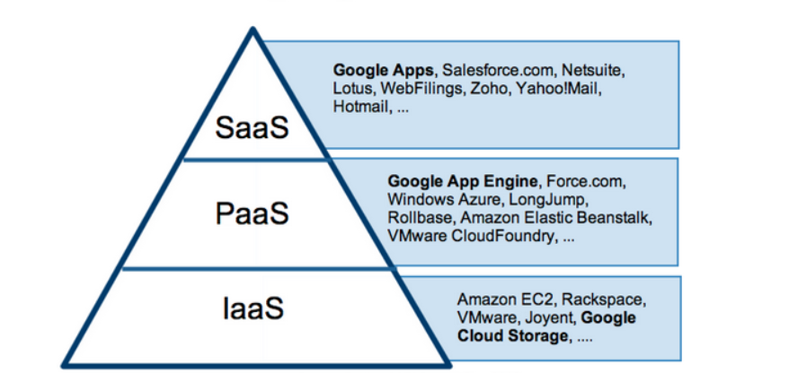

Ref [17]

# SaaS (Software as a Service)

Software as a Service provides users access to application software also known as on-demand software. As these applications run and save all data online users don't need to worry about maintenance, saving or backing up their files. (Google App - Gmail)

# PaaS (Platform as a Service)

Platform as a Service provides users with platforms for users to build and host their own applications. Using PaaS there are no concerns over hardware as the vendor (provider) takes this responsibility. The user must solely focus on their application. (Google App Engine)

# IaaS (Infrastructure as a Service)

Infrastructure as a Service is a way of providing users a cloud computing infrastructure such as servers, storage and operating systems.

Ref [18]

# Advantages of Cloud Computing

* Economically efficient, cloud computing is probably the easiest way to run maintain and upgrade. Many cloud services offer one time payments or pay as you use options.
* Recovery of data, as all your data is stored in the cloud and available over the internet it is easier to retrieve rather than reloading it onto a physical device.
* Practically unlimited storage space
* Versatile compatibility, cloud apps are available on a majority of platforms (PC or Mac)

# Disadvantages of Cloud Computing

* Vulnerability, as data is stored on the internet it is more accessible to hackers, thus chances of sensitive data been leaked to the public.
* Major reliability on network connectivity, if your application is offline then all your data is unreachable.
* Time consuming, it can take a long amount of time to transfer large amount of data to and from the cloud infrastructure.

# Push Notifications

# Push or server push describes a style of Internet based communication where the request for a given transaction is initiated by the publisher or central server.

# 

# HTTP server push known also as HTTP streaming is a mechanism for sending (asynchronous) data from a web server to a web browser. Generally the web server does not terminate the connection after response data has been server to a client. The web server leaves the connection open so that if an event occurs, therefore it can be sent out immediately, otherwise the event (notification) would be queued until the clients next request would have been received.

# Push Notifications on a Mobile Device

# 

# Push notifications allow an app to notify the user of new messages or events without the need to actually have the app running it is similar to how a text message will make a sound and pop up on your screen. Usually a push is done by having an application running in the background, pulling information, or listening to specific events that are pushed from a server.

# 

# Typically you will have a server side application that will register the push notifications service. Once a notification needs to be sent the application server will have to notify the push notification service

# Technologies Used During Project

# Fi-Ware Vision and Goals

The main goal and vision of the Fi-Ware project is to dramatically increase the competitiveness of the European Information and Communications Technology (ICT) [Ref 19] by creating an infrastructure for cost effective development, whilst providing high QoS (Quality of Service) and security. In 2011 the European Commission launched an ambitious Public-Private Partnership (PPP) in order to develop a platform that would be an open source option for global deployment of applications. The PPP resulted in a platform called Fi-Ware Ref [20].

Fi-Ware is an infrastructure for the creation and deployment of applications and services on the internet. Fi-Ware is based on the cloud and intends to become an open alternative for developers and users of the internet.

# Fi-Ware Lab

Fi-Lab is an instance of the Fi-Ware platform that is available for experimenting and testing the Fi-Ware Technologies. Within the fi-lab users are able to set up their virtual infrastructure needed to run applications that make use of the Application Programme Interfaces (APIs) provided by Fi-Ware Generic Enablers.

Ref [21]

# Fi-Ware Generic Enablers

The Fi-Ware technology will be open based upon elements also known as Generic Enablers (GE). GE offer reusable and commonly shared functions across various sectors. Fi-Ware is based on a set of elements called Generic Enablers which are essentially reusable programs.

# 

# Creating a Virtual Infrastructure

Firstly, to set up a virtual infrastructure on the Fi-Ware platform you need to create an account

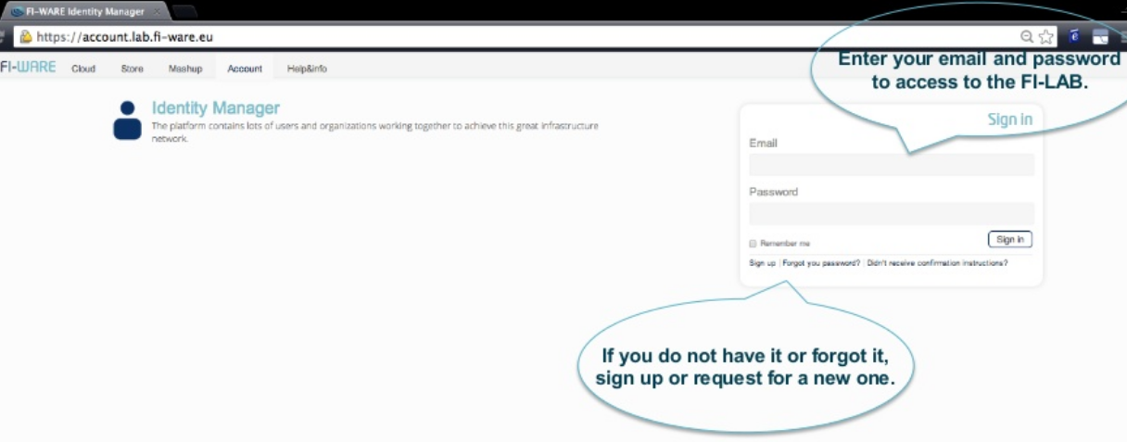

Upon successful login I could select the Cloud Hosting Tab. Inside the Cloud option I firstly had to implement a keypair for access to the servers. Key pairs are SSH (Secure Shell) credentials which are injected into images when they are launched. Creating a new key pair registers the public key and downloads the private key (a .pem file).

To convert the .pem file to a Private Key, I had to download a program called PuTTYgen. PuTTYgen is a program that generates pairs of public and private keys to be used with SSH. After i had downloaded and converted my keypair i then had to open the ports on my virtual machine, port 22 must be open for SSH communication. 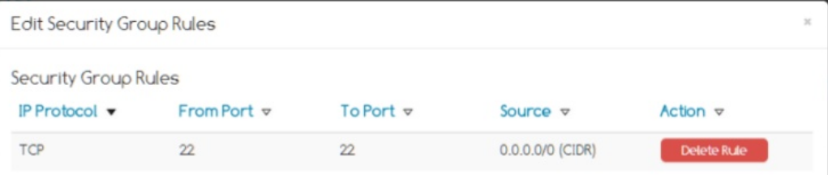

After the security for the virtual machine had been enabled, I then had to allocate a new IP, this IP address would later be assigned along with the security key pair and security rule to a virtual image instance. The virtual image I selected was the CentOS (CentOs is a Linux distribution that attempts to provide a free computing platform which aims to be functionally compatible with its upstream source Red Hat Enterprise Linux (RHEL)) Ref [22].

From the diagram above you can see the following;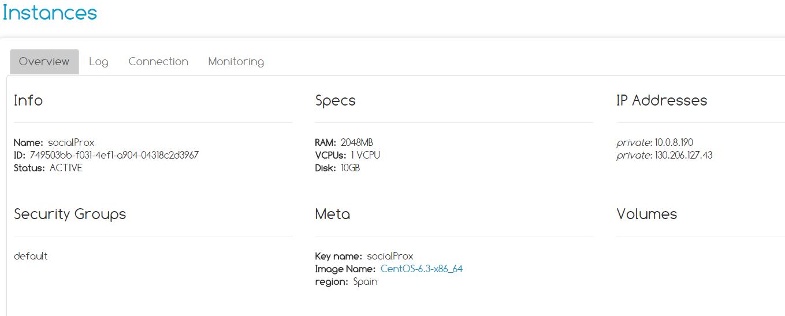

* The instance ‘socialProx’ has been created using the CentOS virtual image.
* The security group named ‘default’ which has ports 22 open for SSH communication.
* The floating IP address 130.206.127.43 has been assigned to the instance.

The next step was to install software on to the virtual image, throughout my research I found two alternatives for doing so one of which was using Blueprint Instances on to the Fi-Ware Cloud portal and the other was a manual install by connecting to the root of virtual machine.

Manual Install

To install software on to the virtual machine hosted on the Fi-Lab I had to connect to the instance. To do this I tried using PuTTY, I entered in the socialProx floating IP Address, the socialProx keypair and finally opening port 22 for SSH communication.

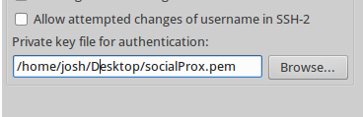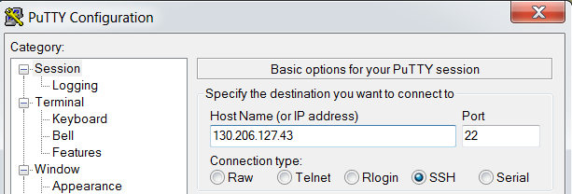

# Java Servlets and Apache Tomcat

Ref [24]

Java servlets are programs that run on a Web or Application server and act as the middle layer between a request coming from a Web browser or other HTTP clients (such as mobile/tablet devices). Using servlets you can collect input from users through web page forms, present records from databases and create web pages dynamically.

# Advantages of Java Servlets

* Performance is significantly better
* Servlets execute within the address space of a Web server
* Servlets are platform-independent as they are written in Java

# Java Servlets Architecture

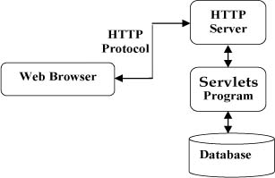

# Servlet Packages

Servlets can be created by using the javax.servlet and javax.servlet.http packages which are a standard part of the Java enterprise edition (JEE). Java Servlets are Java classes run on a web server that has an interpreter that supports the Java Servlet specification.

# Apache Tomcat

Ref [25]

Apache Tomcat is an open source web server and servlet container developed by the Apache Software Foundation. Tomcat implements several Java EE specifications including Java Servlet, JavaServer Pages (JSP), WebSocket and Java EL. Tomcat also provides a pure Java HTTP web server environment for Java code to run in.

# Apache Components

# Catalina

Catalina is Tomcats servlet container. Catalina implements sun microsystems specifications for servlet and JavaServer Pages.

# Coyote

Coyote is a connector component for Tomcat that supports HTTP 1.1 protocol as a web server. Coyote listens for incoming connections to the server on specific TCP port and forwards the request to the Tomcat Engine to process the request and send back a response to the requesting client.

# Jasper

Jasper is Tomcats JSP Engine. Jasper parses JSP files to compile them into Java code as servlets (handled by Catalina). At runtime Jasper detects changes to JSP files and compiles them.

# 

# Version Control

Ref [26]

Version control is a system that records changes to a file or set of files over time so that a user can recall specific versions later. Each version captures a snapshot of the files at a certain point in time. The collection of files is mainly source code for a programming language. However a typical version control can contain any type of file.

The collection of files and their complete history are stored in a repository. A git (Git, the version control used throughout this project) repository contains; a set of commit objects and a set of references to commit objects called heads.

The process of creating different version in the repository is in the diagram below. The snapshots can be used to change your collection of files. An example may be you revert to the collection of files to a state from two days ago as your current application is not working appropriately. 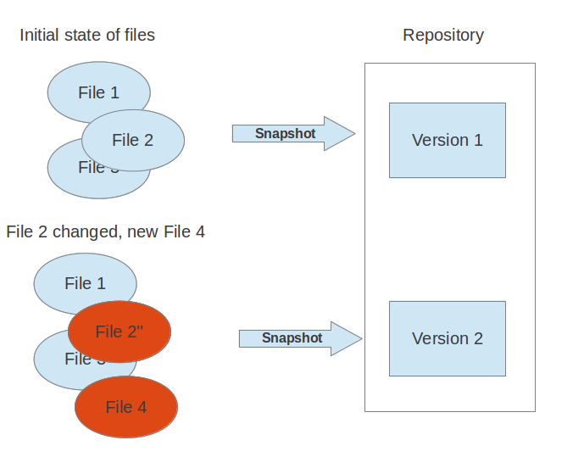

# Git

Git is a distributed version control system. Git originates from the Linux kernel development and is used by many well-known popular projects such as the Android and Eclipse developers. Git was originally written in the programming language C.

# Web Technologies

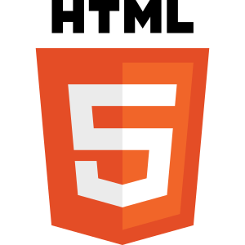

# HTML

Ref [27]

Ref [28]

HTML stands for Hyper Text Markup Language, which is the most widely used language on the web to develop web pages. It is written in the form of HTML elements consisting of tags enclosed in angle brackets (<html>). HTML tag commonly come in pairs one of which opens and the other closes ( <html>,</html>).

Devices that have web browsers can read HTML files and convert them into visible or audio web pages. The web browsers do not show the HTML tags, but do use them to interpret the content of the page.

HTML elements form the building blocks of all websites. HTML allows images and objects to be attached and can be used to create interactive forms. Web browsers refer to Cascading Style Sheets (CSS) to define the look and layout of web pages.

HTML was created by Berners-Lee in 1991 however HTML 2.0 the first standard HTML specification was published in 1995. HTML 4.01 was published in 1999 however as of October 2014 HTML5 was published. HTML5 implemented very beneficial Application Programmable Interfaces such as

1. HTML Geolocation - To get the graphical position of the user
2. HTML Drag and Drop - grab an object and drag it to a different location (e.g. an image)

# CSS

Ref [29]

Ref [30]

Cascading Style Sheets (CSS) is a style sheet language used for describing the look and formatting of a Markup language such as HTML. Whilst mostly used to change the style of web pages and user interfaces the language can also be applied to any kind on XML (Extensible Markup Language). Along with HTML and JavaScript, CSS is an essential technology used by most websites to create visually attractive web pages and user interfaces for mobile applications.

CSS basically handles the look and feel part of web pages, using CSS user can control the colour of text, the style of fonts, spacing between paragraphs, how columns are sized and laid in tables etc. and what background images or colours can be used.

# Advantages of CSS

1. Time efficient - CSS saves time, users can write one CSS and reuse the same sheet in multiple HTML pages, CSS allows you to define a style for each HTML element and apply it to as many web pages as you want.
2. Pages load faster - Using CSS allows the user to write less code. For example you do not need to write HTML tag attributes every time, writing just one CSS rule of a tag and apply it when necessary. Less code means faster download times.
3. Simple Maintenance - making a global change to a tag is simple. Simply change the tag in the CSS sheet and all elements in all the web pages will be updated.
4. Superior style to HTML - CSS provides a much wider array of attributes compared to HTML therefore users can give a far better look to your HTML page.
5. Supported on multiple devices - CSS allow content to be optimized for devices such as mobile phones and tablets.

# JavaScript

Ref [31]

Ref [32]

JavaScript started out known as LiveScript which made its first appearance in 1995. JavaScript is a lightweight interpreted programming language with object-oriented capabilities that allows the user to build interactivity into otherwise fixed HTML pages.

JavaScript is;

1. A lightweight, interpreted programming language
2. Complementary to and integrated with Java and HTML
3. Open and cross-platform

Client Side JavaScript is the most common form of the language. The script should be included in or referenced by a HTML document for the code to be interpreted by the browser. This means the web page will no longer be static HTML, but can now include programs that interact with the user, control the browser and dynamically create vigorous HTML content.

# Advantages of JavaScript

1. \Richer interfaces: users can use JavaScript to include such items such as drag and drop components and sliders to give site viewers a more straightforward user interface.
2. Immediate feedback to viewers: users don't have to wait for error messages on another page, for example with the use of JavaScript to check if a user has entered a valid email address within a form, once they submit the form they will be prompted with an error message immediately.
3. Less server interaction: this is similar to immediate feedback, validating user input before submitting data to a remote server saves server traffic in result this means less load of on your server.

# Disadvantages of JavaScript

1. JavaScript doesn't have any multithreading or multiprocessing capabilities.
2. Client side JavaScript does not allow the reading or writing of files.

# REST API

Ref [33]

Ref [34]

REST is short form of Representation State Transfer. REST is an architectural style web service, RESTful systems typically (but not always) communicate over the Hypertext Transfer Protocol using the same HTTP request protocols (GET, POST, PUT, DELETE, etc.) used by web browser to retrieve web pages and send data to remote servers. RESTful applications make use of HTTP requests. Therefore REST uses HTTP for all four CRUD (Create/Read/Update/Delete).

REST is a lightweight and much easier (to implement) than alternative mechanisms such as RPC (Remote Procedure Calls) and Web Services (SOAP, WSDL). Despite being simple REST is fully featured, there is nothing that can be done in Web Services that can't be done with RESTful architecture.

# Advantages of REST API

1. Platform-independent (you don't care if the server is UNIX, the client is a Mac, or anything else).
2. Language Independent (C# can talk to Java etc.)
3. Standards-based (runs on top of HTTP)

Like Web Services, REST offers not built in security, encryption, session management or Quality of Service. But also with Web Services, these can be added by building on top of HTTP:

1. For security, username/passwords tokens are often used.
2. For encryption, REST can be used on top of HTTPS

# 

# Databases

A database is a collection of information that is organized so that it can easily be accessed, managed, and updated. In computing databases are sometimes classified according to their organizational approach.

# Relational Databases

The most common (popular) approach is the relational database, a tabular database in which data is defined so that it can be recognized and accessed in a variety of ways without having to reorganize the database tables. The relational database was invented by E.F.Codd at IBM in 1970. The standard user and API to a relational database is the structured query language (SQL). SQL statements are used both for interactive queries for information from a relational database.

A relational database is a set of tables containing data fitted into predefined categories. Each table (sometimes known as relation) contains one or more data categories. Each row contains a unique instance of data for the category defined by the columns.

However, the advantage of being relatively easy to create and access a relational database has the important advantage of being easy to extend. After the original database creation a new data category can be added without requiring all the existing applications be modified.

# MySQL

MySQL is the world's second most widely used relational database management system (following SQLite which is deployed in every Android and iPhone along with Chrome and Firefox browser). MySQL is fast and easy to use it is developed marketed and supported by MySQL AB a Swedish company. MySQL is extremely popular because:

1. MySQL is released under and open-source license, users have nothing to pay for using the service
2. MySQL uses a standard form of the well-known SQL data language.
3. MySQL works on many operating systems and with many programming languages such as PHP, C, C++, and Java.
4. MySQL supports large databases, up to 50 million rows or more in a table.

## 

# Distributed Databases

A distributed database is a database in which portions of the database are stored on multiple computers on the network. Users within the network have access to the portion of the database at their location (or what they are working on) so that they can access the data relevant to their tasks without interfering with the work of others.

A centralized distributed database management system (DDBMS) manages the database as if it were stored on the same computer. The DDBMS synchronizes all the data periodically and in cases where multiple users must access the same data the DDBMS ensures that updates and deletes performed on the data at one location will be automatically reflected in the data stored elsewhere.

# 

# Problems Encountered During the Project

# Connectivity with the College Network and Fi-Ware

Unfortunately I encountered some problems here no matter how many times I tried to connect to the virtual machine the socialProx.pem file could not be used. After re-downloading the .ppk file and converting it to a .pem I still could not gain access to my virtual machine.

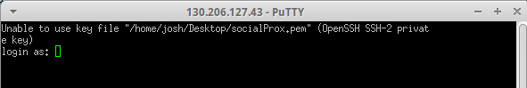

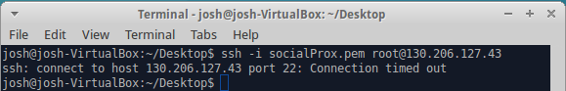After hours of frustration and confusion I decided to test the socialProx.pem file using a Linux based command-line (in my case Xubuntu). But as expected nothing, I then decided to change my network from eduroam to the personal hotspot on my phone.

On eduroam network

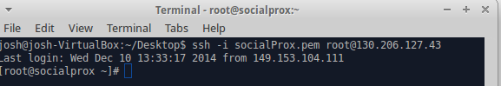Without eduroam network

# Difficulties with Java Servlets and Titanium Appcelerator

I experienced trouble encoding Java Servlet data to JSON format which will be easier to display on Titanium App

*Solved” - The JSON format on the Java Servlet page was a dictionary array of type dictionary not string. I had to create a new JSONObject for each new element. This allowed me to access the contents of the array from the mobile device.

# 

# Posting JSON Data from Mobile Device

I can successfully ‘POST json objects from the titanium application. However i can't seem to display the received JSON object on the Java Servlet page.

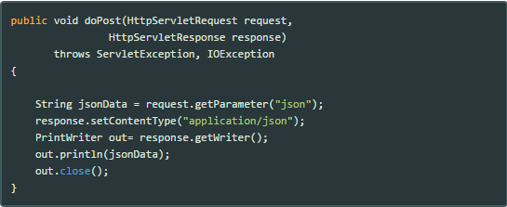



# References

###### Ref [1]

*Proximity, A. (2014). [Online] Play.google.com. Available at:* [*https://play.google.com/store/apps/details?id=com.dreamstep.wProximity&hl=en*](https://play.google.com/store/apps/details?id=com.dreamstep.wProximity&hl=en) *[Accessed 13 Oct. 2014].*

###### Ref [2]

*Oxegen, i. (2014). Oxegen. [Online] App Store. Available at:* [*https://itunes.apple.com/ie/app/oxegen/id379639288?mt=8*](https://itunes.apple.com/ie/app/oxegen/id379639288?mt=8) *[Accessed 6 Nov. 2014].*

###### Ref [3]

*Electric, P. (2014). BandApp. [Online] Bandapp.com. Available at:* [*https://www.bandapp.com/builder/bandpage/electricpicnic*](https://www.bandapp.com/builder/bandpage/electricpicnic) *[Accessed 13 Oct. 2014].*

###### Ref [4]

*Native, A. (2014). What is native app? - Definition from WhatIs.com. [Online] Searchsoftwarequality.techtarget.com. Available at:* [*http://searchsoftwarequality.techtarget.com/definition/native-application-native-app*](http://searchsoftwarequality.techtarget.com/definition/native-application-native-app) *[Accessed 14 Oct. 2014].*

###### Ref [5]

*Worldwide Smartphone Shipments Edge Past 300 Million Units in the Second Quarter; Android and iOS Devices Account for 96% of the Global Market, According to IDC. [Online] www.idc.com. Available at:* [*http://www.idc.com/getdoc.jsp?containerId=prUS25037214*](http://www.idc.com/getdoc.jsp?containerId=prUS25037214) *[Accessed 14 Oct. 2014].*

###### Ref [6]

*Publishing, G. (2014). Get Started with Publishing | Android Developers. [Online] Developer.android.com. Available at:* [*http://developer.android.com/distribute/googleplay/start.html*](http://developer.android.com/distribute/googleplay/start.html) *[Accessed 14 Oct. 2014].*

###### Ref [7]

*iOS, l. (2014). [Online] Famouslogos.org. Available at:* [*http://www.famouslogos.org/wp-content/uploads/2013/04/ios-logo.jpg*](http://www.famouslogos.org/wp-content/uploads/2013/04/ios-logo.jpg) *[Accessed 14 Oct. 2014].*

###### Ref [8]

*Rating, i. (2014). Apple App Store hits 60 billion cumulative downloads. [Online] Engadget. Available at:* [*http://www.engadget.com/2013/10/22/apple-ios-7-downloaded-over-200-million-times-in-5-days/*](http://www.engadget.com/2013/10/22/apple-ios-7-downloaded-over-200-million-times-in-5-days/) *[Accessed 14 Oct. 2014].*

###### Ref [9]

*Platform, N. (2014). What is Web application (Web app)? - Definition from WhatIs.com. [Online] Searchsoftwarequality.techtarget.com. Available at:* [*http://searchsoftwarequality.techtarget.com/definition/Web-application-Web-app*](http://searchsoftwarequality.techtarget.com/definition/Web-application-Web-app) *[Accessed 15 Oct. 2014].*

###### Ref [10]

*Docs, G. (2014). What is Google Docs? - Definition from WhatIs.com. [Online] Whatis.techtarget.com. Available at:* [*http://whatis.techtarget.com/definition/Google-Docs*](http://whatis.techtarget.com/definition/Google-Docs) *[Accessed 6 Nov. 2014].*

###### Ref [11]

*Docs, G. (2014). Google Docs - create and edit documents online, for free.. [Online] Google.ie. Available at:* [*http://www.google.ie/docs/about/*](http://www.google.ie/docs/about/) *[Accessed 6 Nov. 2014].*

###### Ref [12]

*GoogleDoc, P. (2012). Course: Information Technology Class: Google Docs: Advantages and Disadvantages. [Online] Itlabgmu.blogspot.ie. Available at:* [*http://itlabgmu.blogspot.ie/2012/02/google-docs-advantages-and.html*](http://itlabgmu.blogspot.ie/2012/02/google-docs-advantages-and.html) *[Accessed 6 Nov. 2014].*

###### Ref [13]

*Hybrid, P. (2014). Native, HTML5, or Hybrid: Understanding Your Mobile Application Development Options - developer.force.com. [Online] Developer.salesforce.com. Available at:* [*https://developer.salesforce.com/page/Native,_HTML5,_or_Hybrid:_Understanding_Your_Mobile_Application_Development_Options*](https://developer.salesforce.com/page/Native,_HTML5,_or_Hybrid:_Understanding_Your_Mobile_Application_Development_Options) *[Accessed 15 Oct. 2014].*

###### Ref [14]

*Appcelerator.com, (2014). Titanium Mobile Application Development | Appcelerator Inc. [online] Available at:* [*http://www.appcelerator.com/titanium/*](http://www.appcelerator.com/titanium/) *[Accessed 16 Oct. 2014].*

###### Ref [15]

*Titanium, S. (2014). [Online] Appcelerator.com. Available at:* [*http://www.appcelerator.com/wp-content/uploads/titanium-studio-elements1.png*](http://www.appcelerator.com/wp-content/uploads/titanium-studio-elements1.png) *[Accessed 6 Nov. 2014].*

###### Ref [16]

*HowStuffWorks, (2014). How Cloud Computing Works - HowStuffWorks. [Online] Available at:* [*http://computer.howstuffworks.com/cloud-computing/cloud-computing.htm*](http://computer.howstuffworks.com/cloud-computing/cloud-computing.htm) *[Accessed 8 Nov. 2014].*

###### Ref [17]

Sandeepkejriwal.com, (2014). [Online] Available at: <http://sandeepkejriwal.com/wp-content/uploads/2013/05/Iaas-PaaS-SaaS-as-per-Gartner.jpg> [Accessed 8 Nov. 2014].

###### Ref [18]

*Infrastructure, C. (2014). What are SaaS, PaaS and IaaS? With examples. [Online] Stackoverflow.com. Available at:* [*http://stackoverflow.com/questions/16820336/what-is-saas-paas-and-iaas-with-examples*](http://stackoverflow.com/questions/16820336/what-is-saas-paas-and-iaas-with-examples) *[Accessed 8 Nov. 2014].*

###### Ref [19]

*Forge.fi-ware.org, (2014). Overall FI-WARE Vision - FI-WARE Forge Wiki. [Online] Available at:* [*https://forge.fi-ware.org/plugins/mediawiki/wiki/fiware/index.php/Overall_FI-WARE_Vision#Vision_and_Goals*](https://forge.fi-ware.org/plugins/mediawiki/wiki/fiware/index.php/Overall_FI-WARE_Vision#Vision_and_Goals) *[Accessed 9 Nov. 2014].*

###### Ref [20]

*Hackforgood.net, (2014). FI-WARE – HackForGood | HackForGood. [Online] Available at:* [*http://hackforgood.net/fi-ware-en/*](http://hackforgood.net/fi-ware-en/) *[Accessed 10 Nov. 2014].*

###### Ref [21]

*Accountlab.fi-ware.org, (2014). FIWARE Identity Manager. [Online] Available at:* [*https://account.lab.fi-ware.org/users/sign_in*](https://account.lab.fi-ware.org/users/sign_in) *[Accessed 10 Nov. 2014].*

###### Ref [22]

Wikipedia, (2014). CentOS. [Online] Available at: <http://en.wikipedia.org/wiki/CentOS> [Accessed 11 Nov. 2014].

###### Ref [23]

*Blogs.telerik.com, (2012). What is a Hybrid Mobile App? [Online] Available at:* [*http://blogs.telerik.com/appbuilder/posts/12-06-14/what-is-a-hybrid-mobile-app-*](http://blogs.telerik.com/appbuilder/posts/12-06-14/what-is-a-hybrid-mobile-app-) *[Accessed 9 Nov. 2014].*

###### Ref [24]

*Jenkov, J. (2015). Java Servlets | tutorials.jenkov.com. [Online] Tutorials.jenkov.com. Available at:* [*http://tutorials.jenkov.com/java-servlets/index.html*](http://tutorials.jenkov.com/java-servlets/index.html) *[Accessed 28th Dec. 2014].*

###### Ref [25]

*Tomcat.apache.org, (2015). Apache Tomcat 8 (8.0.17) - Documentation Index. [Online] Available at:* [*http://tomcat.apache.org/tomcat-8.0-doc/index.html*](http://tomcat.apache.org/tomcat-8.0-doc/index.html) *[Accessed 28th Dec. 2014].*

###### Ref [26]

*Version Control - Git. Version Control. [Online] Available at:* [*http://tomcat.apache.org/tomcat-8.0-doc/index.html*](http://www.vogella.com/tutorials/Git/article.html#versioncontrolssystems) *[Accessed 31 Mar. 2015].*

###### Ref [27]

*HTML Tutorial- HTML. [Online] Available at:* [*http://www.tutorialspoint.com/html/*](http://www.tutorialspoint.com/html/) *[Accessed 31 Mar. 2015].*

###### Ref [28]

*HTML - HyperText Markup Language [online] Available at:* [*http://en.wikipedia.org/wiki/HTML#HTML_versions_timeline*](http://en.wikipedia.org/wiki/HTML#HTML_versions_timeline) *[Accessed 31st Mar. 2015].*

###### Ref [29]

*CSS - Cascading Style Sheets. [Online] Available at:* [*http://en.wikipedia.org/wiki/Cascading_Style_Sheets*](http://en.wikipedia.org/wiki/Cascading_Style_Sheets) *[Accessed 2nd April 2015].*

###### Ref [30]

*CSS Tutorial - CSS [online] Available at:* [*http://www.tutorialspoint.com/css/*](http://www.tutorialspoint.com/css/) *[Accessed 2nd April 2015].*

###### Ref [31]

*JavaScript Tutorial [online] Available at:* [*http://www.tutorialspoint.com/javascript*](http://www.tutorialspoint.com/javascript) *[Accessed 2nd April 2015].*

###### Ref [32]

*JavaScript [online] Available at:* [*http://en.wikipedia.org/wiki/JavaScript*](http://en.wikipedia.org/wiki/JavaScript) *[Accessed 2nd April 2015].*

###### Ref [33]

*Learn REST - Tutorial [online] Available at:* [*http://rest.elkstein.org/*](http://rest.elkstein.org/) *[Accessed 3rd April 2015].*

###### Ref [34]

*REST - Representational State Transfer [online] at:* [*http://en.wikipedia.org/wiki/Representational_state_transfer*](http://en.wikipedia.org/wiki/Representational_state_transfer) *[Accessed 3rd April 2015].*